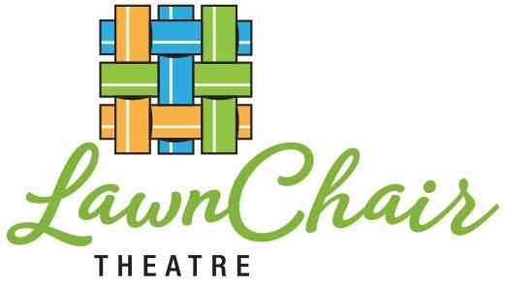 ABOUT LAWNCHAIR THEATRE

Who We Are: LawnChair Theatre has brought outdoor performances to Westchester’s parks since 2006. We feature multi-generational casts that blend professionally trained and amateur performers. Our favorite playwright is Shakespeare, the English language’s most enduring writer, whose works still speak to us.

Our Mission: Theatre has the power to raise the level of empathy in the world. To that end, we present Shakespeare’s plays as contemporary works. We travel to a diverse range of towns, performing in public spaces. In our work and play, we intentionally create loving and inclusive community.
Past Productions: As You Like It, The Tempest, The Taming of the Shrew, Much Ado About Nothing, Twelfth Night, Two Gentlemen of Verona, Romeo & Juliet…
Contact: hello@lawnchairtheatre.org, Peter Green, Artistic Director, 914-414-1226. LawnChair Theatre is a registered 501C3. www.lawnchairtheatre,org/donate
A Midsummer Night’s Queen 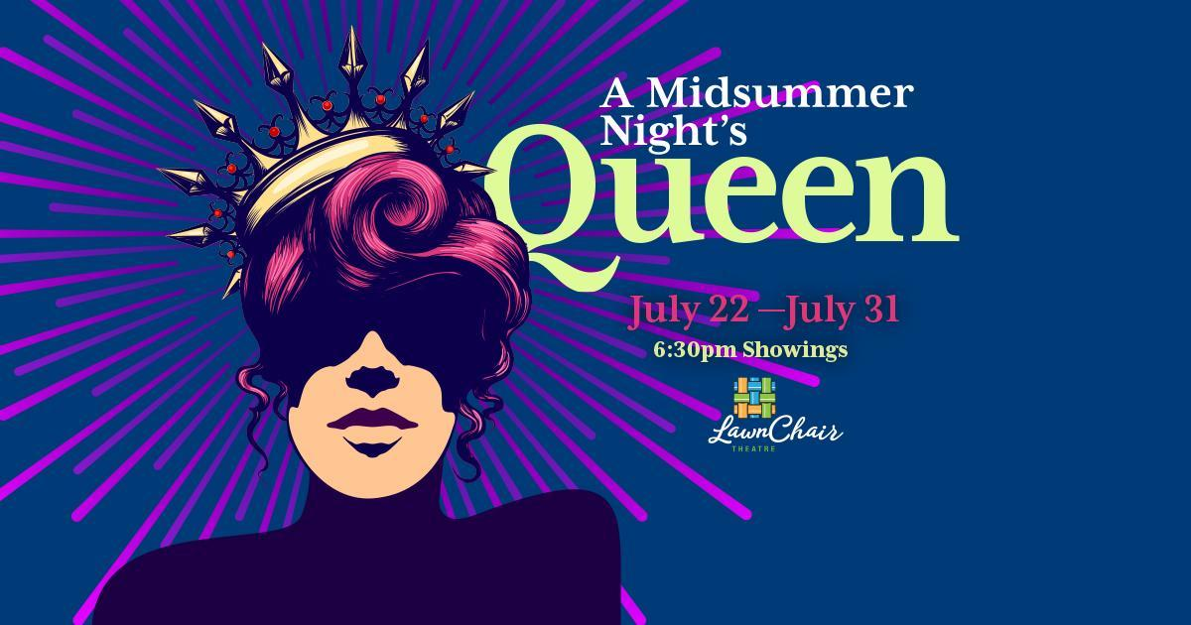
Last summer, we crafted a theatrical experience pairing Shakespeare’s sonnets, soliloquies, and scenes with the songs of the Beatles. This summer, we’ve united A Midsummer Night’s Dream with the music of Queen. Our production is a musical celebration and a fun-filled dream, perfect for a midsummer evening. A Midsummer Night’s Queen is set in the modern day. Musical numbers include Don’t Stop Me Now, We are the Champions, Fat Bottom Girls, Killer Queen, Bohemian Rhapsody, and others. The show runs roughly two hours.
Creative Team: A Midsummer Night’s Queen is the adaptation of Mat Young, who has been directing, acting and teaching theatre in Westchester and Fairfield Counties for over 20 years. Our arranger and musical director is Broadway & International composer/conductor/ arranger Keith Levenson, symphonic conductor for The Who’s world tour.
The Cast: There are 24 lively performers in this summer’s cast, including a singing Fairy chorus. They range in age from 21 to 65. Most of them have professional training and/or experience. Half have been seen in previous LawnChair productions.

