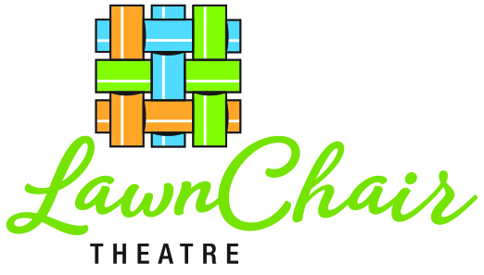
FOR IMMEDIATE RELEASE CONTACT: CARIN ZAKES
www.lawnchairtheatre.org CARIN@LAWNCHAIRTHEATRE.ORG
914-325-1812

OUTDOOR THEATRE IS BACK THIS SUMMER!
LAWNCHAIR THEATRE PRESENTS
A MIDSUMMER NIGHT’S QUEEN at 5 Westchester Venues

7/22: Village Green, Rye
7/23 & 7/24: Rye Town Park
7/25: The Armory, New Rochelle
7/28: Rain Date, Rye Town Park
7/29: Private Benefit Performance
7/30: Recreation Field, Chappaqua
7/31: Bedford Playhouse Lawn
8/01: Bedford Rain Date
Rye, NY— 6/08/21: Starting this July, LawnChair Theatre is back for its 16th season, with a musical adaptation of Shakespeare’s renowned fantasy-comedy that the whole family can rock out to. Featuring a cast of 23 pro-am local performers and 17-person crew, Westchester’s best traveling summer entertainment is a true community venture featuring live band performances of songs by the legendary rock group Queen.
Adapted and directed by veteran theatre actor and director Mat Young, with music arrangements and direction by The Who’s global tour conductor and Broadway professional Keith Levenson, the show will run about 120 minutes and feature Queen hits like, “Don’t Stop Me Now,” “We Are The Champions” and “Bohemian Rhapsody.”
Show Your Love with “Live Aid” Adoptions Putting the “fun” in fundraising, this year LawnChair audiences are invited to support the production by “adopting” favorite parts of the show! Visual Aid supports sets, costumes and lighting; Roll Aid helps trucking and traveling; Band Aid benefits musicians and equipment. Shows are free but tax-deductible donations are gratefully accepted on site. Visit www.lawnchairtheatre.org for more about how to donate, plus parking, raindate and venue details.

LawnChair Theatre is a partner organization of the Rye Arts Center. The company is fully vaccinated and follows the latest CDC guidelines for audience, cast and crew safety. All performances begin at 6:30 pm. Show dates and locations are as follows:

# # #

